

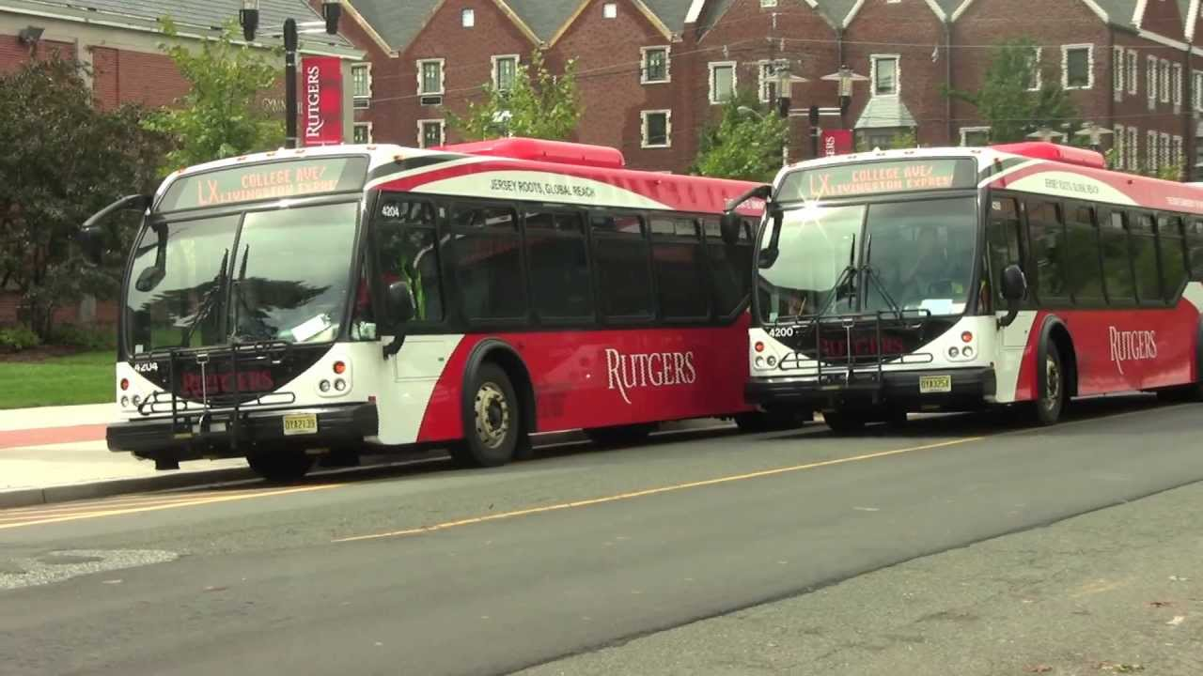

SUPERLOOP SHUTTLE

BY,

Naveen Dayakar Velpur

Khavya Ramachandran

Xiuwen Lin



### 

### Table of Contents

* + 1. Project Definition Document…………………………………………………………………...  3
       1. Purpose………………………………………………………………………………………  3
       2. Scope………………………………………………………………………………………….  3
       3. Goals & Objectives………………………………………………………………………  3
       4. Success Criteria…………………………………………………………………………..  3
       5. Assumptions……………………………………………………………………………..… 3
       6. Constraints……………………………………………………………..............................  4
       7. Risks…………………………………………………………………………………………..  4
       8. Stakeholders……………………………………………………………………………… 4
       9. Out of Scope Specifications…………………………………………………………. 4
       10. Project Dependencies………………………………………………………………….. 5
    2. Work Breakdown Structure…………………………………………………............................ 6
    3. Project Schedule…………………………………………………………………………………….. 7
    4. Project Schedule (Gantt Chart)….…………………………………………………………….. 8
    5. Project Budget…………………………………………………………………………………......... 9
    6. Risk Management Plan…………………………………………………………………………… 10
       1. Potential Risks………………………………………………………............................... 11
       2. Probability Impact Matrix……………………………………………………………. 12
       3. Risk Severity Matrix…………………………………………………………………….. 13
       4. Risk Response Plan…………………………………………………………………….... 14
    7. Quality Management Plan……………………………………………………………………….. 16
       1. Project Quality Control……………………………………………………………….... 16
       2. Project Quality Assurance…………………………………………………………….. 16
       3. Quality Team Roles and Responsibilities………………………………………. 17
    8. Communication Management Plan…………………………………………........................ 19
    9. Stakeholder Analysis Matrix……………………………………………………………………. 21
    10. Customer Acceptance Form…………………………………………………………………….. 23

### PROJECT DEFINITION DOCUMENT

Purpose

* To implement and maintain the shuttle service between Newark and New Brunswick Rutgers Campuses; overcome the transportation difficulty faced by students travelling between the two campuses.

Goals and Objectives

* To plan a shuttle service for the students travelling between Newark and New Brunswick Rutgers Campus
* Plan the operation of the shuttle, get necessary approvals and implement it within the time frame of the project
* Minimize students missing classes due to the distance between the campus and encourage them to take classes from both the campus.
* Maintain the operations with minimum delays and operate the shuttle in the right time to ensure students can take classes in both the campus on the same day.

Success Criteria

* To get approval by completing the test-run, with not more than 3 test runs.
* To get approval from the board for the budget.
* The schedule for the shuttle should be finalized and operations should start in 3-month time frame.
* All the test-runs for the approval and time scheduling must also be within the time allotted for the entire project.
* All planning and test-runs should not exceed beyond the budget.
* To accomplish at least 4 round trips per day between the campuses.
* To have less than 3 or no breakdowns per month.

Assumptions

* More drivers are recruited for operating the SuperLoop shuttle and RUDOTS is ready to fund.
* NJDOT approves the free toll pass for all the SuperLoop shuttles.
* The Test-run is approved by both NJDOT and RUDOTS.
* There is enough fund to buy more buses for the SuperLoop Shuttle.
* The Rutgers board decides to fund the project.
* Three months are sufficient to complete the test-run, buy more buses, allot appropriate time, and bring the shuttle service up and running.
* Time to commute the shuttle one-way is standard across all the seasons.
* Extreme Weather conditions absent.
* Buses do not have breakdowns often, and back up buses are available.

Constraints

* Time constraint to make the SuperLoop up and running in 3 month time.
* The test run must be run and all the improvements necessary to be done in the time limit.
* Budget constraint as the budget should cover all the breakdowns and repair costs.
* Limited number of days to hire extra drivers, and buy more buses.
* Time constraint for the approval of free toll pass for the SuperLoop shuttle.
* Coordinate time and date of various entities involved.

Risks

* Frequent bus breakdown.
* Driver/crew injury, sickness, or unavailability.
* Unforeseeable breakdown and repair costs.
* Need for multiple test runs.
* Funding not approved.
* Funding reduced in future.
* Extreme Weather Conditions.
* Exceeding Budget.
* Operation start date is postponed.
* Strike by workforce.

Stakeholders

* Rutgers President / Board
* Student Body
* Project Team
* Department of Transportation Services (DOTS)
* NJ Department of Transportation(NJDOT)
* Crew/Bus Drivers

Scope

* Pre-Test-Run Phase (Document the schedule, number of buses and stops, hire crew, assign the schedule)
* Test Run Phase (Check the availability of the drivers, travel time, approval from all boards)
* Post Test-Run Phase (Follow the timings, revise timings, conduct surveys, review complaints/suggestions portal should be checked weekly)

Out-of-Scope Specifications

* Maintenance of other Newark/ New Brunswick Shuttles
* Connection services to other campuses.
* Connection stops to other Shuttles apart from SuperLoop.
* Operation of SuperLoop during holidays.
* Allotting SuperLoop shuttle drivers to other shuttles.

Project Dependencies

* Availability of Drivers and Crew.
* Availability of buses.
* Approval to operate in the route from NJDOT.
* Approval from the Rutgers Board.
* Ability to operate the long-distance shuttle in Extreme Weather Conditions.

### WORK BREAKDOWN STRUCTURE

1. Initiation of Shuttle Service
   1. Obtain approval from Management
   2. Determine budget to get approval
   3. Determine stops and timings of the shuttle
2. Planning
   1. Determine the frequency of the shuttle
   2. Determine the number of people who use the service
   3. Identify the number of buses required
   4. Develop a plan with the number of stops to be included
   5. Consider the possible routes
   6. Identify the peak times where more than one bus is needed
3. Requirements
   1. Operations to be started within 3 months
   2. From the initiation of project, to the first shuttle run, should be within budget
   3. Successful completion of test run
   4. Continue Operations with less than 3 breakdowns per month
   5. Accomplish 4 roundtrips a day between the campus
   6. Adding the shuttle to the existing shuttle-tracking app
   7. Creating a complaints/suggestions portal should not exceed budget.
4. Determining the shuttle timings and frequency
   1. Develop a document with the frequency of shuttle
   2. Find the number of students to be travelling
   3. Fix the number of stops at New Brunswick and Newark campus
   4. Determine the number of buses needed
   5. Determine the number of drivers that need to be hired
   6. Assign the schedule for the drivers and crew
5. Test Run
   1. Check the number of students who are travelling
   2. Check the availability of the drivers
   3. Determine the travel time for each time of the day
   4. Check the service under various weather conditions
   5. Assign back up plans in case of emergency
   6. Get approval from the Rutgers Board, NJDOT, RUDOT group
   7. Repeat the test runs if necessary
6. Post Test Run
   1. Arrange for back up buses in case of any emergency
   2. Approval of free toll pass
   3. Ensure the timings of the shuttle is followed.
   4. Revise the timings of the shuttle when needed.
   5. Quarterly surveys to be conducted for the shuttle service
   6. Complaints/suggestions portal should be checked weekly.

### Project Schedule

In project management, a schedule is a listing of a project's milestones, activities, and deliverables, usually with intended start and finish dates. The project schedule should be updated on a regular basis to gain a better understanding of the project’s current status. Below is the schedule for the SuperLoop Shuttle:

Superloof%20Shuttle.pdf

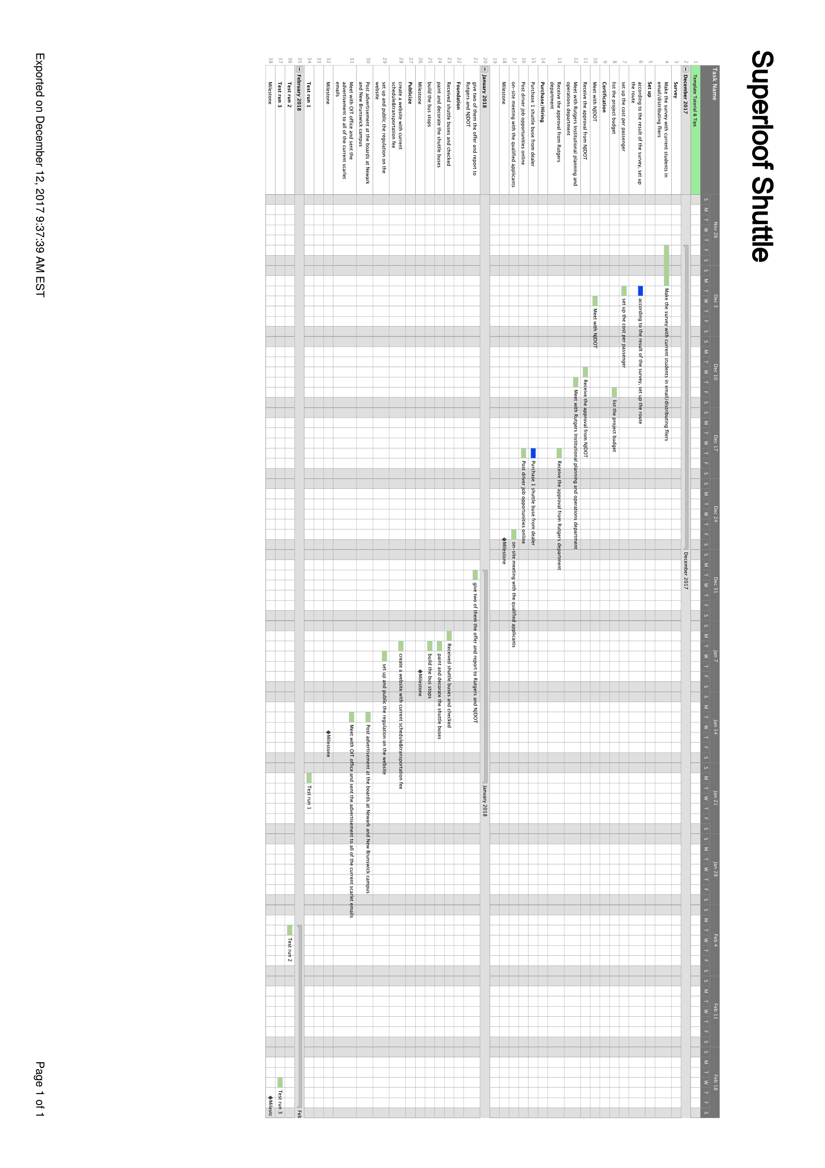

### Project Budget

The project budget contains all the major factors influencing the project from a financial perspective. However, most of the itemized budget represents an approximate cost for the entire year. The initial set up costs like buying the shuttle bus, and other one-time activities listed do not repeat yearly. They are part of implementation costs.



### Risk Management Plan

The goal of managing project risks is to identify and prepare for any potential threat to the project’s critical success factors before it occurs. As a result, risk management is the essence of managing projects. To protect the project from any risks and to properly mitigate the risks we have used a predictive approach. Below are the potential risks that may impact the critical path of the project in any way.

Potential Risks:

|  |  |  |
| --- | --- | --- |
| Risk | Description | Time of Occurrence |
| 1. Bus Breakdown | The bus may breakdown frequently, and this may happen due to the long distance the shuttle is supposed to travel, many trips per day. | Operations phase, post test-run. |
| 2. Driver/crew injury, sickness, or unavailability. | A Driver or crew member may get sick or injured before their shift, thus causing them to be unavailable. | Mainly during operations phase, post test-run.  Replacing a driver is the difficult part, especially after the project is completed and on-going. |
| 3. Unforeseeable breakdown and repair costs | Buses need to be monitored and repaired now and then to ensure safety. | Mainly during operations phase, post test-run. May occur during test-run phase also. |
| 4. Need for multiple test runs. | Multiple routes and time frames have to be tested out, to gain knowledge on average time required for a one-way trip. | Test-Run Phase |
| 5. Funding not approved. | The Rutgers Board may not approve the funding, if the budget is not feasible. | Pre-Test run Phase. |
| 6. Funding reduced in future. | The Board may cut-off the budget if primarily things go according to plan. The Board may see opportunity cost and invest the risk budget to some other project where  there is a need for potential investment. | Post Test-Run Phase |
| 7. Exceeding Budget | Unforeseen weather conditions, repair costs due to long distance, hike in fuel prices, may lead to exceeding budget. | Post Test-Run Phase |
| 8. Project start date is postponed | The project might not start on the fixed date due to multiple test-runs, driver unavailability, or longer time in getting approval from board and NJDOT. | All three phases. The project schedule gets affected as a whole. |
| 9. Permissions/Licenses denied | NJDOT does not approve the project due to the traffic and speed limit regulations of the shuttles. | Test-run and Post Test-run phase. |
| 10. Strike by workforce | Drivers/ crew members or the people responsible to monitor and control the SuperLoop shuttles can do a labor strike. | All three phases. |

|  |  |  |  |  |  |  |  |
| --- | --- | --- | --- | --- | --- | --- | --- |
| **PROBABILITY IMPACT MATRIX** | | | | | | | |
| *RISK* | *PROBABILITY* | IMPACT | IMPORTANCE | | CATEGORY | | OWNER |
| 1. Bus Breakdown | 4 | 5 | 20 | | Quality | | Jason |
| 2. Driver/crew injury, sickness, or unavailability | 3 | 3 | 9 | | Labor | | Rachel |
| 3. Unforeseeable breakdown and repair costs | 3 | 4 | 12 | | Financial | | Thomas |
| 4. Need for multiple test runs | 3 | 2 | 6 | | Quality | | Mike |
| 5. Funding not approved | 2 | 5 | 10 | | Financial | | Tom |
| 6. Funding reduced in future | 1 | 4 | 4 | | Financial | | Khloe |
| 7. Exceeding Budget | 4 | 3 | 12 | | Financial | | Thomas |
| 8. Project start date is postponed | 3 | 4 | 12 | | Management | | Jim |
| 9.Permissions/Licenses denied | 2 | 5 | 10 | Management | | Jim | |
| 10. Strike by workforce | 4 | 4 | 16 | Labor | | Rachel | |
| Scale = 1 (Low) : 5 (High) | | | | | | | |

Risk Severity Matrix

A Risk severity matrix is used during risk assessment to define the various levels of risk as the product of the probability categories and severity categories. This is a simple mechanism to increase visibility of risks and assist management in decision making. All the risks that fall into the red block should be our main priority.

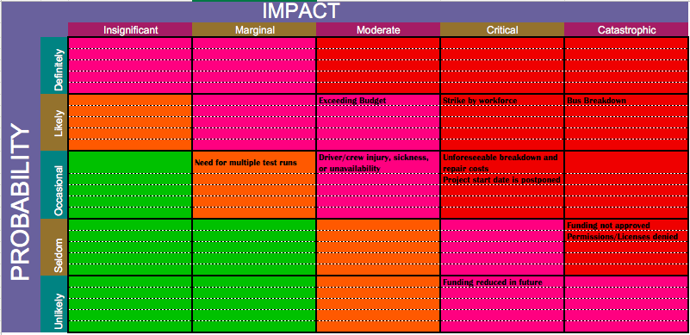

Risk Response Plan

Below are the responsive actions, plans and options to eliminate the risks or reduce their impact on the project if they ever become actionable. Each risk can have various responses like Mitigation, Monitor and prepare, Transference, Acceptance etc.,

|  |  |  |
| --- | --- | --- |
| Risk | Risk Response | Description |
| 1. Bus Breakdown | Mitigation | Prepare backup buses in case the bus breakdown occurs and also have subsequent measures to send a backup vehicle to tow the bus or provide repair on spot. |
| 2. Driver/crew injury, sickness, or unavailability | Mitigation | Having a backup plan in case a worker does not show up. Extra human resources should be hired, more than the number which is actually necessary. |
| 3. Unforeseeable breakdown and repair costs | Monitor and prepare | Have financial resources allocated for unforeseeable situations. Include the extra resources needed into the project budget, keeping these situations in mind. |
| 4. Need for multiple test runs | Mitigation | Prepare incase multiple test runs are required, to create proper time schedule for the shuttle, and also make sure safety is ensured. Extra financial resources should. |
| 5. Funding not approved | Mitigation | Change the project budget by allocating more resources to high risk factors and important tasks only. Seek more funds. Organize fundraising events. |
| 6. Funding reduced in future | Avoidance | Seek more funds. Organize fundraising events. Get insurance for accidents and other breakdown events. |
| 7. Exceeding Budget | Monitor and Prepare | Seek more funds. Organize fundraising events. Get insurance for accidents and other breakdown events. |
| 8. Project start date is postponed | Avoidance | Monitor the scope of the project and follow the project schedule. Concentrate on the critical path of the project in case of shortage of time. |
| 9.Permissions/Licenses denied | Mitigation | Look for other options like reapplying for other licenses & locations, and altering the project plan to get the license approved. |
| 10. Strike by workforce | Monitor and prepare | Monitor the satisfaction of the work force, ensure safety of the workers etc.. |

*Contingency Reserves



### QUALITY MANAGEMENT PLAN

|  |  |
| --- | --- |
| Prepared by: | SuperLoop – Project Management Team |
| Date: | 12/13/2017 |

|  |
| --- |
| 1. Quality Policy & Standards |
| *Quality Policy & Standards will follow industry standards, as well as, standards enforced by local governance. Each Project Manager (PM) will implement and follow stated policies.* |

|  |
| --- |
| 2. Project Quality Definition |
| *Project quality is defined as customer satisfaction, timely inspections, corrections/improvements where necessary, responsible stakeholders, cost of quality investment within projection with the project finishing on time within the scope and budget.* |

1.1 Project Quality Control:

The focus of quality control is on the deliverables of the project. Quality control monitors project deliverables to verify that the deliverables are of acceptable quality and are complete and correct.

The following table identifies:

* The major deliverables of the project that will be tested for satisfactory quality level.
* The quality standards and the correctness and completeness criteria established for the project deliverable. Included are any organizational standards that need to be followed.
* The quality control activities that will be executed to monitor the quality of the deliverables.
* How often or when the quality control activity will be performed.

| Project Deliverable | Deliverable Quality Standards/  Completeness and Correctness Criteria | Quality Control Activity | Frequency/Interval |
| --- | --- | --- | --- |
| Bus condition | QC1. Conforms to expert commentary regarding bus condition | Transport authority review  Board approval | Weekly |
| Maintenance of vehicle | QC2. Conforms to transport owner company regarding the bus maintenance. | Transport authority review | Monthly |
| Shuttle service stops | QC3. Conforms to the RUDOTS and project team. | Board approval | Quarterly |

1.2 Project Quality Assurance:

The focus of quality assurance is on the processes used in the project. Quality assurance ensures that project processes are used effectively to produce quality project deliverables.

The following table identifies:

* The project processes subject to quality assurance.
* The quality standards and stakeholder expectations for that process.
* The quality assurance activity – such as a quality audit or reviews - that will be executed to monitor that project processes are properly followed.
* How often or when the quality assurance activity will be performed.

|  |  |  |  |
| --- | --- | --- | --- |
| Project Process | Process Quality Standards/  Stakeholder Expectations | Quality Assurance Activity | Frequency/Interval |
| QA1. Develop project charter  QA2. Execute and control project per project plan    QA3. Approve each project stage during test run  QA4. Close project with post test run review | 100% compliance with plan  95% compliance with framework  100% compliance with framework  100% compliance with framework | Audit charter updates by phase  Audit the following activities:   * Bus stop times * Bus shuttle stops * Bus shuttle timings   Audit stage checkpoints  Audit project reviews by phase | Once per project phase  Weekly  Monthly  Monthly  Once per project phase/stage  Once per project phase |

1.3 Quality Team Roles & Responsibilities:

The following identifies the quality-related responsibilities of the project team and lists specific quality responsibilities.

| Project Team Role | Assigned Resource | Quality Control and Quality Assurance Responsibilities |
| --- | --- | --- |
| Executive Sponsor | John - Executive Sponsor | QA4: Approve each project stage per requirements  QA1, QA2, QA3, QA4: Assess practice of project management framework activities  QC3: Assess satisfactory resolution of project management gaps |
| PMO Director | Naveen-PMO Director | QC3: Assess satisfactory resolution of project management gaps  QA4: Approve each project stage per requirements |
| Senior Project Manager | Khavya – Senior Project Manager | QA3: Assure practice of quality control measures and communications in project plan  QC1, QC2, QC3: Assure framework and PMA reviews by Core Team, Review Team, Mechanical team  QC1, QC2, QC3: Communicate prioritized changes per Review Team review |
| Senior Project Lead | Lin- Senior Project Lead | QA1, QA2, QA3, QA4: Assess practice of project management framework activities |
| Quality Manager | Mike, Jason– Transport Quality Executive | QC1: Confirm vehicle meets safety standards  QC7: Confirm back up plans in case of emergencies  QC8, QC9: Test buses for extreme conditions |
| Driver | Names - Driver | QA2: Ensures to follow the proper bus shuttle timings and stops. |

### Communications Management Plan

# introduction

## Purpose of Communications Management Plan

The overall objective of a Communications Management Plan is to promote the success of a project by meeting the information needs of project stakeholders. The *Customer Acceptance Form* Communications Management Plan (CMP) defines the project’s structure and methods of information collection, screening, formatting, and distribution and outline understanding among project teams regarding the actions and processes necessary to facilitate the critical links among people, ideas, and information that are necessary for project success.

The intended audience of the *SuperLoop* CMP is the project manager, project team, project sponsor and any senior leaders whose support is needed to carry out communication plans.

# 

# stakeholder Communication Matrix

|  |  |  |  |  |
| --- | --- | --- | --- | --- |
| Name | Department | Title | Communication | Mode of Communication |
| Naveen Dayakar | PMO | PMO Director | Project Workgroup Meeting Reports, Decisions | Email Only |
| Khavya Ramachandran | PMO | Senior Project Manager | Project Monthly Status Reports, Decisions, Improvements | Email, Meetings |
| Xiuwen Lin | PMO | Senior Project Lead | Project Monthly Status Reports, Decisions, Improvements | Email, Meetings |
| Jim | Operations | Management  Lead | Project Monthly Status Reports, Decisions | Email, Phone, Meetings, Webex |
| Thomas | Finance | Senior Finance Manager | Project Budget, Monthly Reports | Email, Phone, Meetings, Webex |
| Tom | Finance | Finance Manager | Project Budget, Monthly Reports | Email, Phone, Meetings, Webex |
| Khloe | Finance | Finance Manager | Project Budget, Monthly Reports | Email, Phone, Meetings, Webex |
| Mike | Operations | Quality Manager | Project Budget, Monthly Reports, Project Completion Reports | Email, Phone, Meetings, Webex |
| Jason | Operations | Quality Manager | Project Budget, Monthly Reports Completion Reports | Email, Phone, Meetings, Webex |
| Rachel | Human Resource | HR Recruiter | Project Budget, Monthly Reports, Recruitment Details | Phone, Email |

The stakeholder communication matrix represents the deliverables expected by the stakeholders, the mode of communication in which the expectations met are documented.

# 

# Communications Protocol

## Communications Matrix

The communication matrix represents the objectives of a communication, the intended audience, along with the owner of the communication. These elements are conducted at frequent intervals, to ensure the critical path and the timeline of the project are not compromised.These steps act as a guideline or checklist that ensure that the project is moving in the expected speed.

|  |  |  |  |  |  |  |
| --- | --- | --- | --- | --- | --- | --- |
| Communication Type | Objective | Medium | Frequency | Paticipants | Owner | Deliverable |
| Kickoff Meeting | Introduce the project team and the project, review project objectives and management approach. | -Face to Face | Once | Rutgers Board, PMO Director, Project Team and Lead | Project Manager | -Agenda |
| Project Workgroup Meetings | Develop high level project plans and protocols. | -Face to Face  -Conference call  -Webex | Bi-weekly | Project Team | -Project Manager  -Project Leads | -Agenda  -Project Schedule  -Project Updates |
| Weekly PMO Meetings | Discuss and develop solutions for the project | -Face to Face | -weekly or as needed | Project team | -PMO director | -Agenda  -Project Updates  -Project Decisions |
| Site Visit | In accordance with project activities. Identify and discuss problems and solutions for project obstacles. | -Face to Face | As needed | All project partners  Project Team | Project coordinator and internal/ external control expert | Identify project status and recommendation for improvement. |
| Monthly RUDOTS Meetings | Report on the status of the project to the board | -Face to Face | Monthly | Project Team, RUDOTS team and Rutgers Board | RUDOTS Lead | Agenda - Meeting materials  - Process of reporting meeting outcomes/recommendations to stakeholders and RUDOTS leadership |
| Project Status Reports | Report on the status of the project including activities, progress, costs and issues. | Email | Monthly | Project Team, RUDOTS Team | Project Manager | Project Monthly Status Reports |

### 

### Stakeholder Analysis Matrix

|  |  |  |  |  |  |  |  |  |
| --- | --- | --- | --- | --- | --- | --- | --- | --- |
| Name | Department | Title | Expectations | Influence | Interest | Involvement | Impact | Stakeholder Category |
| John | Project Sponsor | Sponsor | The project is efficient and serves the purpose, operates at the expected level with minimum breakdowns and difficulties. | High | High | High | High | Important Player- Keep Informed Daily |
| Naveen Dayakar | PMO | PMO Director | Ensure that the project meets the stakeholders expectations, communicate with stakeholders. | High | High | High | High | Important Player- Keep Informed Daily |
| Khavya Ramachandran | PMO | Senior Project Manager | Ensure that the project is in line with the scope, schedule and budget set by the sponsor. | High | High | High | High | Important Player- Keep Informed Daily |
| Xiuwen Lin | PMO | Senior Project Lead | Report any major issues and develop reports on the progress of the project. | Low | High | High | High | Key Player – keep informed |
| Jim | Operations | Management  Lead | Responsible for coordinating the different teams of the project and to ensure that the project continues to operate just like that initiation period. | Medium | High | Low | High | Keep Informed |
| Thomas | Finance | Finance Manager | Communicate with the Project Sponsor about the progress, also any changes that influence the financial budget. | High | Medium | Low | High | Keep Informed |
| Tom | Finance | Finance Manager | Communicate with the Project Sponsor about the progress, also any changes that influence the financial budget. | High | Medium | Low | High | Keep Informed |
| Khloe | Finance | Finance Manager | Communicate with the Project Sponsor about the progress, also any changes that influence the financial budget. | High | Medium | Low | High | Keep Informed |
| Mike | Operations | Quality manager | Ensure the standards of the shuttle bus is maintained, vehicle is inspected regularly. | High | Medium | Low | High | Keep Informed |
| Jason | Operations | Quality manager | Ensure the standards of the shuttle bus is maintained, vehicle is inspected regularly. | High | Medium | Low | High | Keep Informed |
| Rachel | Human Resource | HR Recruiter | Ensure the appropriate number of personnel are available, crew is allotted work efficiently and manage worker relations. | High | Medium | Low | High | Keep Informed |
| Drivers | Operations | Driver | Operate the bus, with minimum breakdowns, within safety levels and ensuring comfort. | Medium | Medium | High | Low | Keep Satisfied |
| Students | Client | Commuter | To comply with the workers. | High | Low | Low | High | Affected Player - Keep Satisfied |

### Customer Acceptance Form

[SUPERLOOP SHUTTLE]

Version 1.0 - Issued November 28, 2017

This document is used to obtain the customer's sign-off once the project is complete.

|  |  |
| --- | --- |
| Project: [SUPERLOOP SHUTTLE] | |
| This document has been issued by: [Khavya] | Date Issued:11/29/2017 |

|  |  |
| --- | --- |
| The Project Outcome has been measured against its acceptance criteria and has been formally accepted on behalf of the customer. The project may now be closed. | |
| Additional Comments about the Customer Acceptance: | |
|  | |
| Recorded Shortfalls of the Final Project Outcome (if any): | |
|  | |
| Executive / Sponsor:  PMO Director:  Senior Project Manager: | Signature: _________________________  Name: John  Date:  Signature: _________________________  Name: Naveen  Date: _________________________  Signature: _________________________  Name: Khavya  Date:_________________________ |